2025 CQUMCM
Problem B: The Millennium-Old Hydraulic Project _____ Dujiangyan

Dujiangyan is not only a popular tourist destination but also a millennium-old hydraulic project. It is no exaggeration to say that Dujiangyan contributed to the prosperity of the Bashu region and, further, to its cultural and historical development. Astonishingly, as early as over two thousand years ago, this project designed and constructed by Li Bing reached a level that even aligns with modern scientific principles, making it a marvel that integrates hydraulics, mathematics, and physics.
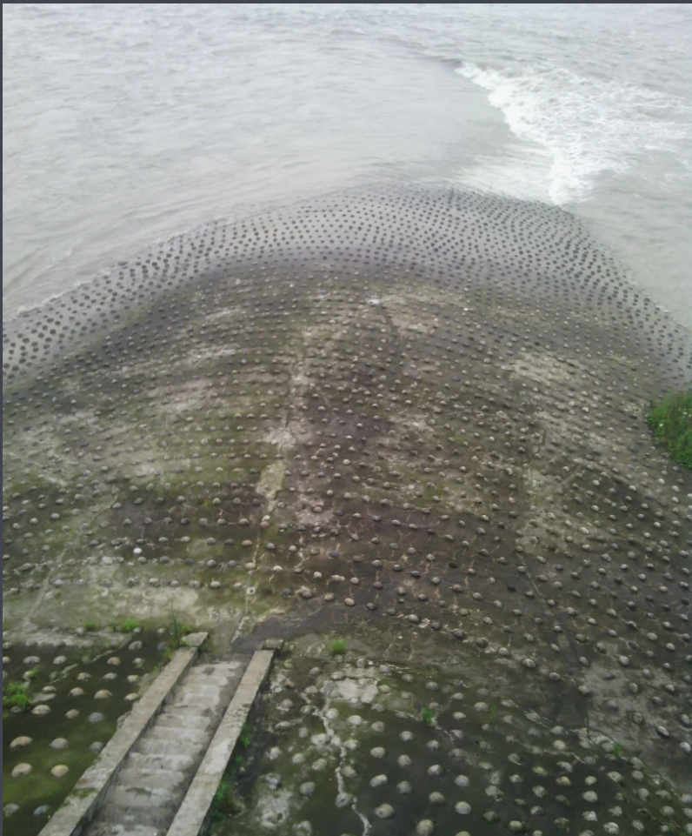
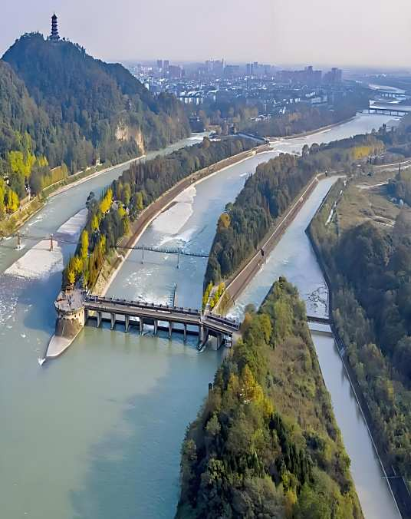

Source: Baidu

Your team is requested to use mathematical models to illustrate the mathematical principles behind the design of Dujiangyan and to verify your results by consulting relevant data.

(1) Water Division Model
Tour guides often explain that the design of Dujiangyan achieves a 60-40 split between the Inner River and Outer River during the dry season, and a 40-60 split during the flood season. Using relevant hydrological data and geometric measurements of Dujiangyan, calculate the flow ratio between the two rivers under different total flow conditions. Based on historical water volume and rainfall data, analyze the distribution of water flow in the Inner River, with a particular focus on extreme drought and flood scenarios.

(2) Sediment Discharge Model
Several key features of Dujiangyan effectively facilitate sediment discharge, significantly reducing the sediment concentration in the Inner River. Use mathematical models to explain how Dujiangyan achieves this and determine the sediment concentration in the Inner River under varying flow rates and sediment loads.

Your PDF solution of no more than 25 total pages should include:
• One-page Summary Sheet.
• Table of Contents.
• Your complete solution.
• References list.
• AI Use Report (If used does not count toward the 25-page limit.)

Note: There is no specific required minimum page length for a complete MCM submission. You may use up to 25 total pages for all your solution work and any additional information you want to include (for example: drawings, diagrams, calculations, tables). Partial solutions are accepted. We permit the careful use of AI such as ChatGPT, although it is not necessary to create a solution to this problem. If you choose to utilize a generative AI, you must follow the COMAP AI use policy. This will result in an additional AI use report that you must add to the end of your PDF solution file and does not count toward the 25 total page limit for your solution.

